**Veer Narmad South Gujarat University, Surat.**

**M.Sc. (Information Technology) Programme**

# Project Report

**6th Semester**

**M.Sc. (Information Technology)**

**5 Years Integrated Course**

Year 2019 – 2020

## E Farming

Guided By : Submitted By :

### Mr. Parvez Khan Nandakrishnan U. Nair (57)

### Kishan A.Vala (105)

**MaheshPalSingh K. Jadon (31)**

#### Node2Begin

F-22 Agreseen Shopping Point, Besides Agraseen Bhavan Citylight, Surat



.

**Veer Narmad South Gujarat University, Surat.**

**Department of Information and Communication Technology**

**M.Sc. (I.T.) Programme**

**Certificate**

This is to certify that Mr./Miss. **Nair Nandakrishnan Unnikrishnan** Exam Seat Number: **57** and have satisfactorily completed his/her project work entitled **E-Farming** as a partial fulfilment of the requirements for **6th** ***Semester - B.Sc. (Information Technology)*** during the academic Year 2019-2020.

Date : 8 Aug 2020

**Course Co-ordinator**

Place : Surat **M.Sc. (I.T.) Programme.**

**Veer Narmad South Gujarat University, Surat**

|  |
| --- |
| Node2Begin |
| Pocket Farm |
| We bring you closer than ever before… |

MaheshPal Singh Jadon, Kishan Vala, Nandakrishnan Nair

**Index**

|  |  |  |
| --- | --- | --- |
| Sr. No. | Particulars | Page No. |
| 1. | **Introduction**   * 1. **Project Profile**   2. **Company Profile** | 8  9 |
| 2. | **Hardware and Software requirements**  **2.1 Hardware Configuration**   * 1. **Software Configuration**   2. **Server Configuration** | 11 |
| 3. | **Proposed System**   * 1. **Problem Statement**   2. **Purpose**   3. **Scope**   4. **Objective** | 13  14  15 |
| 4. | **System Analysis**   * 1. **Software Requirement Specification**   2. **ER Diagram**   3. **Use Case diagram**   4. **Data flow diagram**   5. **Data Dictionary**   6. **Process Specification**   7. **Database design**   8. **Activity Diagram**   9. **Class Diagram**   10. **Site Map diagram** | 17  18  19  22  29  33  46  54  58 |
| 5. | **System Planning**   * 1. **Duration Feasibility**   2. **Implementation Feasibility**   3. **Operational Feasibility**   4. **Technical Feasibility**   5. **Resource Feasibility**   6. **Behavioural Feasibility**   7. **Economic Feasibility**   8. **Software Engineering Model** | 63  64  65  66 |
| 6. | **Test Cases**   * 1. **Admin side**   2. **User side** | 68  69 |
| 7. | **Limitations** | 73 |
| 8. | **Future Enhancements** | 74 |
| 9. | **Screenshots** | 75 |
| 10. | **References** | 84 |

**1. Introduction**

**1.1 Project Profile**

**1.2 Company Profile**

* 1. **Project profile**

**1.1.1 The Concept:**

Pocket Farm is a live web based application with MySQLi database where Farmers can post an auction on their freshly harvested products that are ready for sale, where Customers can Bid for those products to buy the product of their choice at best price. It includes multiple search options, to make the product easily accessible to our customers & Farmers can post auctions easily with the friendly User interface.

You can find it on-

|  |  |
| --- | --- |
| **Project Title** | **Pocket Farm** |
|  |  |
| **Organization** | Node2begin |
| **Front End Tools** | PHP,MVC,Javascript,Jquery & Ajax |
| **Back End Tools** | MySQLi |
| **Other Tools** | Task Scheduler,VBscript,HTML5,CSS3 & BOOTSTRAP 4 |
| **Project Category** | Web Based application |
| **Project Associates** | Three |
| **Duration** | Three Months |
| **Internal Project Guide** | Ms. Lissa John |
| **External Project Guide** | Mr. Parvez Khan |
| **Submitted By** | Kishan Vala , MaheshPalSingh Jadon, Nandakrishnan Nair |
| **Submitted To** | Department of ICT |
|  |  |

* 1. **Company Profile**



1. **Hardware and Software requirements**
   1. **Hardware Configuration**
   2. **Software Configuration**
   3. **Server Configuration**

**2.1 Hardware Configuration :**

|  |  |
| --- | --- |
| **Processor** | : 2.40 GHz Intel(R) Core(TM) i5-6200U |
| **Hard Disc** | : 1 TB |
| **RAM** | : 4 GB |
| **CD Drive** | : hp DVDRW GUD1N |
| **Key Board** | : Standard PS/2 Keyboard |
| **Mouse** | : Synaptics SMBus TouchPad |
| **Monitor** | : Generic PnP Monitor |
| **Networking device** | : Lan Card (Must be internet connection) or modem |

* 1. **Software Configuration**
* **XAMPP Server 3.2.4**
* **Google Chrome, Mozilla Firefox**
* **Sublime Text 3**
  1. **Server Configuration**
* **Apache version:**
  + - **Apache/2.4.37**
* **PHP version:**
  + - **PHP 7.2.14**
* **MySQL Version:**
* **MySQL 5.7.24**

1. **Proposed System**
   1. **Problem Statement**
   2. **Purpose**
   3. **Scope**
   4. **Objective**
   5. **Problem Statement**

Problem Statement is on the basis of both our users- Farmers and Buyers.

**Buyers**

* Buyers get the products at three to four times higher price .
* Buyers don’t get farm fresh products, with minimal artificial processing.

**Farmers**

* Farmers don’t get the Price for their crops worth the hardwork they put in.
* Buyers are under limited reach due to geographical conditions.
  1. **Purpose**

* To bring Farmers and Customers close.
* To let Farmers meet their price demands.
* To let customers have products at cheaper Prices .
  1. **Scope**
* **Admin**
* Admin can manage the Categories.
* Admin can manage the Tags.
* Admin can view and manage their Profile (personal).
* Admin can view Users
* **Farmer**
* Farmer can view and manage their Profile
* Farmer can Register their Products
* Farmer can post an auction on registered products
* Farmer can edit the Auction details.
* Farmer can view Bids on their products
* Farmer can sell the products to the highest bidder
* Farmer can End the auction.
* Farmer can reset password.
* Farmer can also register as Customer.
* **Buyer**
* Buyer can View products by Category, Tags, Farmer, etc
* Buyer can Search for products by Product name, Farmer, City.
* Buyer can post Bids on products that are being Auctioned.
* Buyer can view Farmers profile.
* Buyer can view and manage their Own profile.
* Buyer can Rate the Farmer
* Buyer can Reset Password.

**3.4 Objective**

* To provide complete transparency between Farmer and Customer.
* To make Farmer and customer reachable despite of geographical conditions.

1. **System Analysis**
   1. **Software Requirement Specification**
   2. **ER-Diagram**
   3. **Use Case Diagram**
   4. **Data Flow Diagram**
   5. **Data Dictionary**
   6. **Process Specification**
   7. **Database Design**
   8. **Activity Diagram**
   9. **Class Diagram**
   10. **Site Map Diagram**
   11. **Software Requirement Specification**
       1. **Non Functional Requirements**

* Transparency between buyer and seller
* Easy to use User Interface
* Recoverability
* Response time
  + 1. **Functional Requirement**
* Logins and Registrations
* View profiles
* View by Category, Product Name, Season.
* Search by keyword, farmer name, category, product name
* Password recovery
* Start and End Bid
* Apply for the Bid
* Provide Review /add comments
  1. **ER-Diagram**

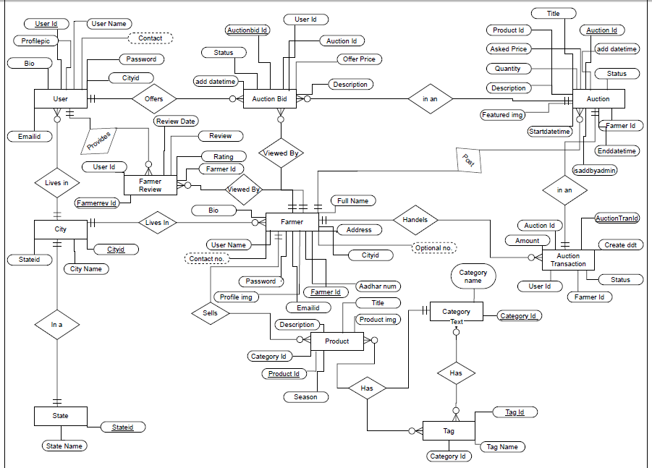

* 1. **Use Case Diagram**
     1. **Admin**

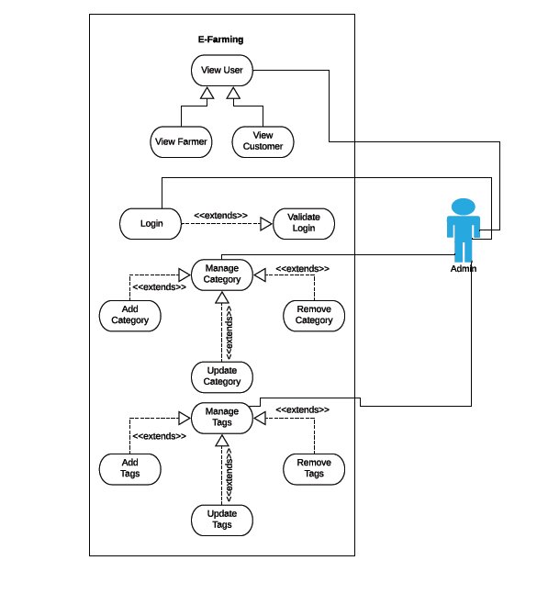

* + 1. **Farmer**

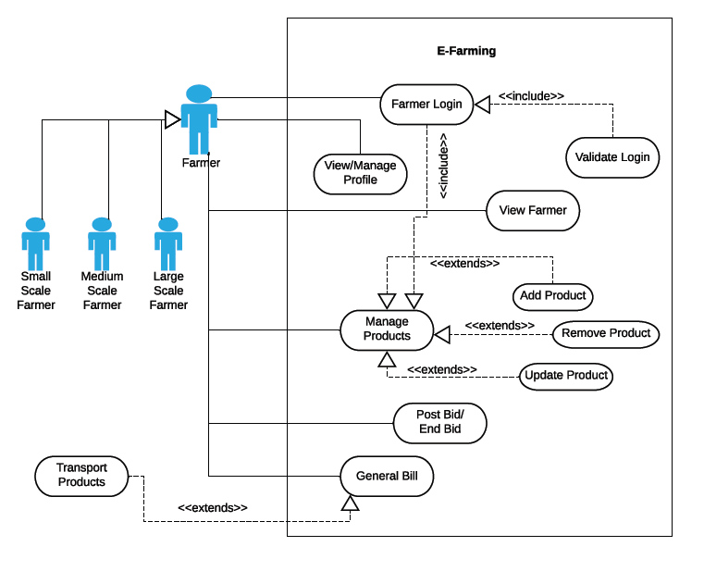

* + 1. **Customer**

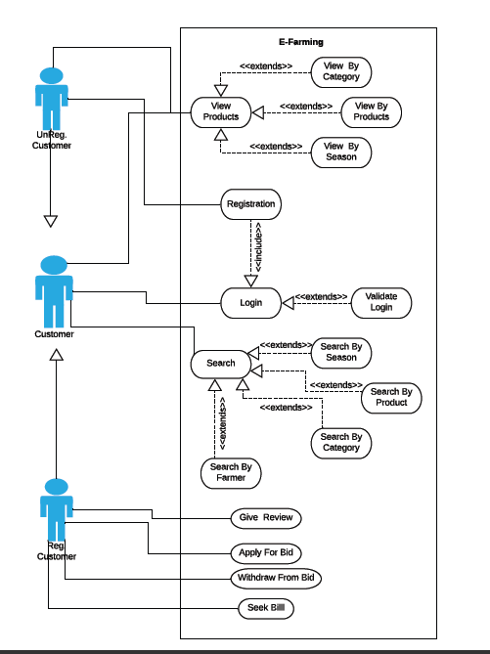

* 1. **Data Flow Diagram**

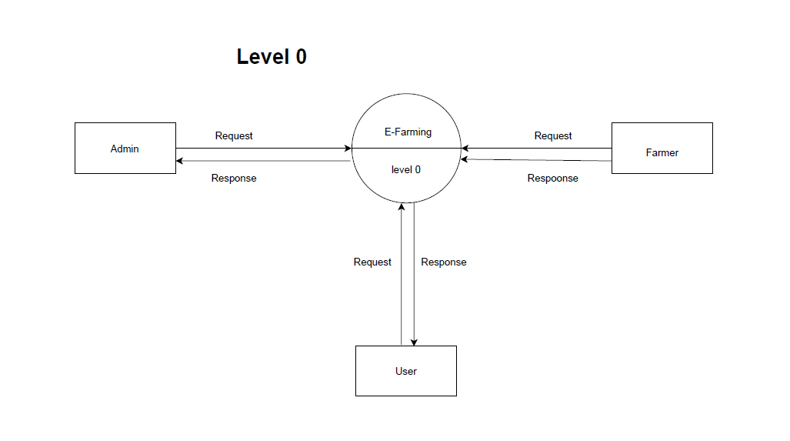

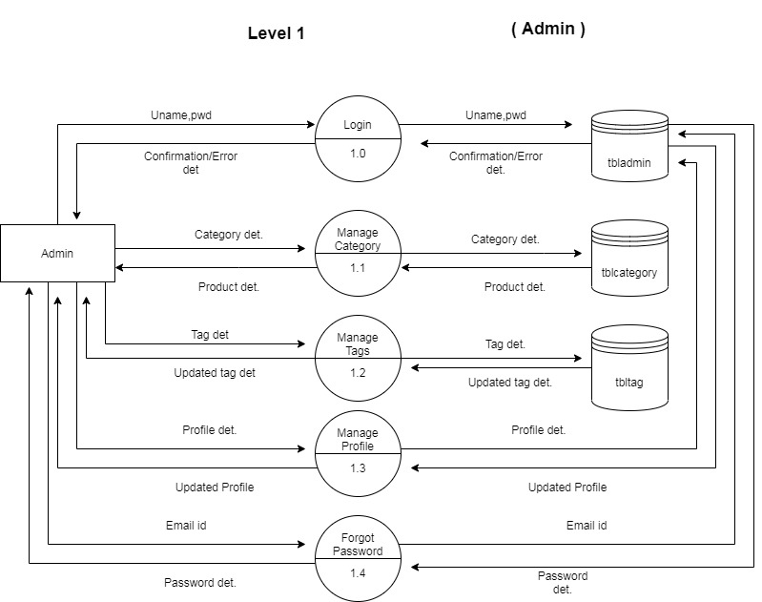

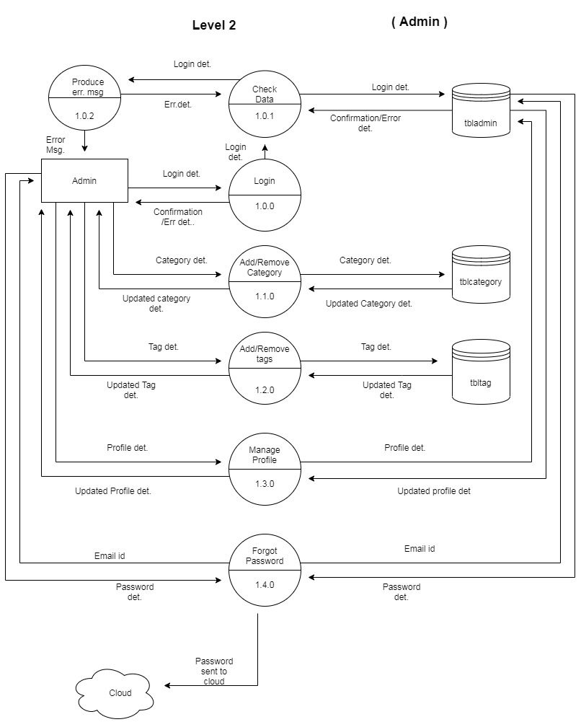

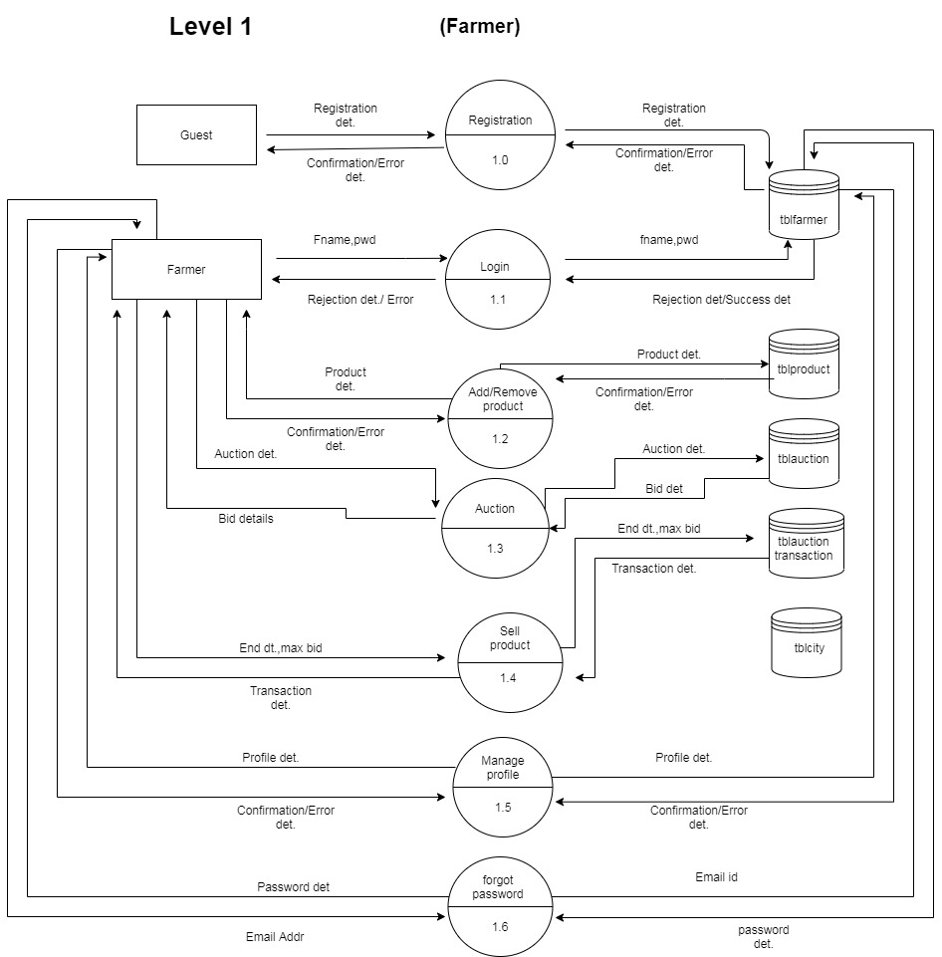

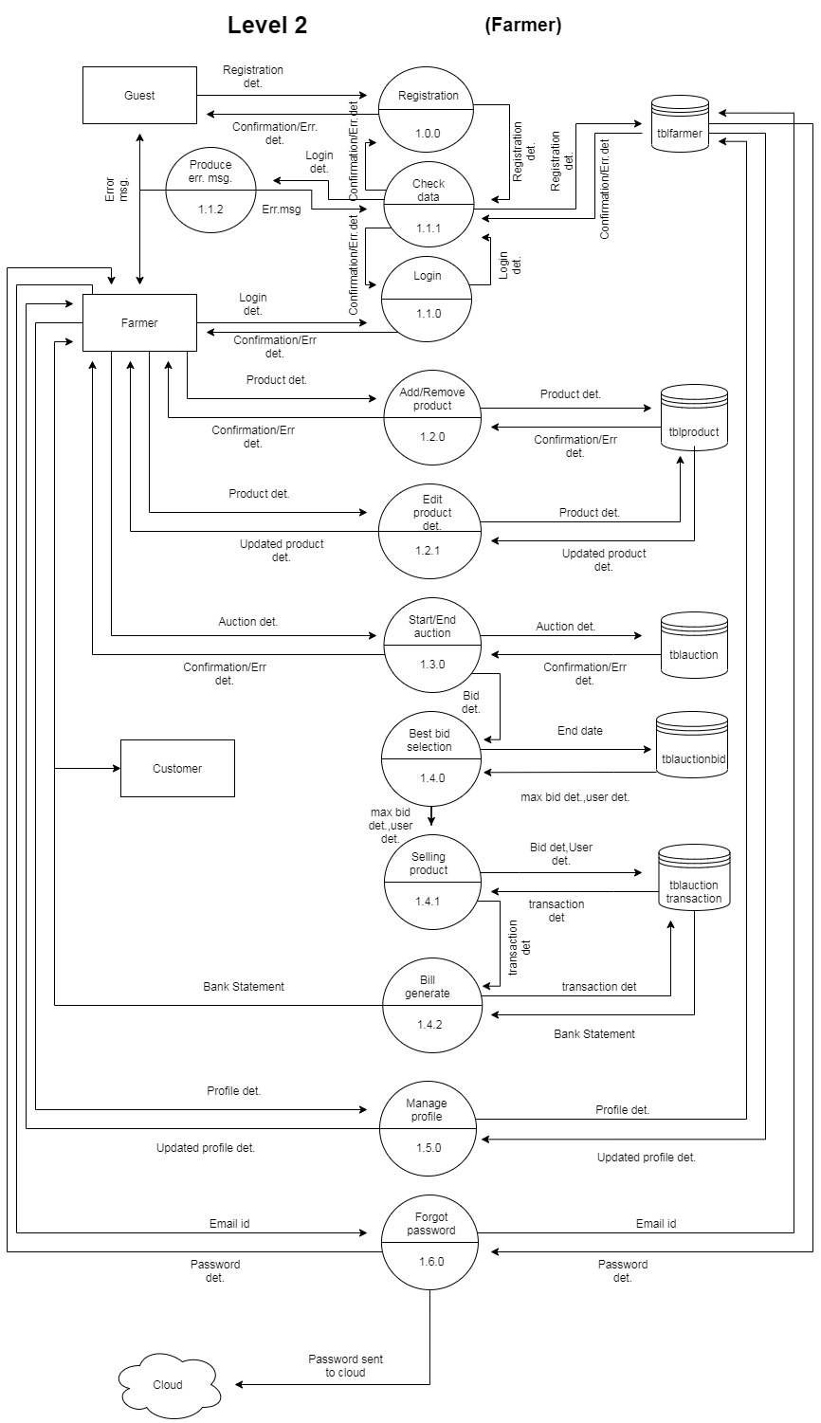

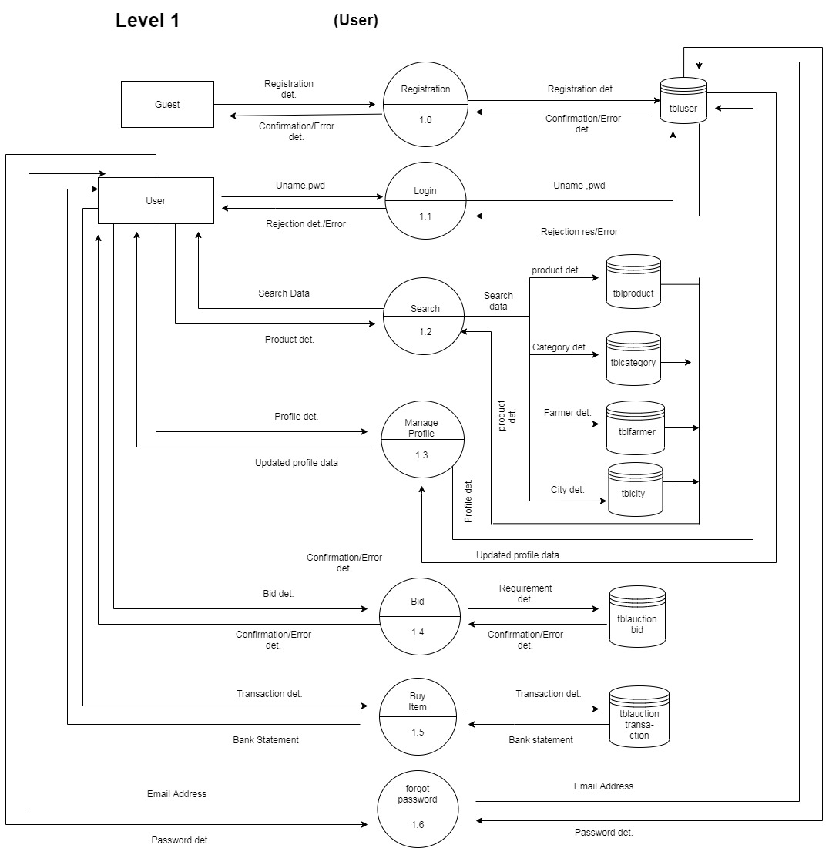

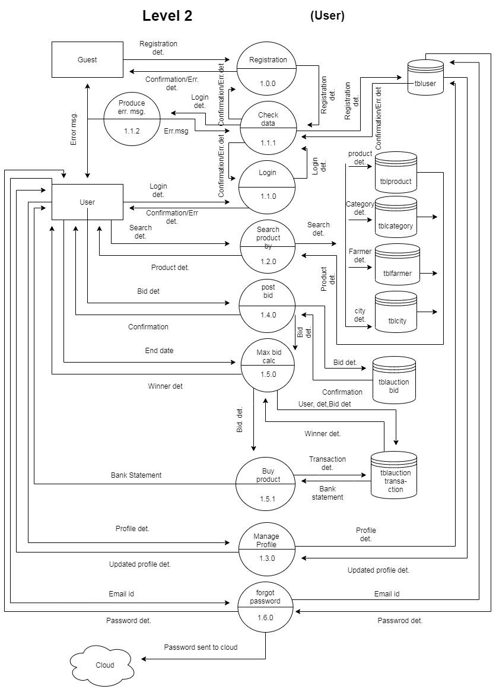

* 1. **Data Dictionary**

|  |  |
| --- | --- |
| **Name** | Uname |
| **Description** | Username of the logged in user |
| **Alias** | fname |
| **When/Where Used** | Input to login and registration |

|  |  |
| --- | --- |
| **Name** | pwd |
| **Description** | Password of the registered user |
| **Alias** | Password |
| **When/Where Used** | Input to login and registration |

|  |  |
| --- | --- |
| **Name** | Tag det. |
| **Description** | Tag details about the product |
| **Alias** | tag det. |
| **When/Where Used** | Input to and output from manage tags process |

|  |  |
| --- | --- |
| **Name** | Category det. |
| **Description** | Category details of the product |
| **Alias** | category det. |
| **When/Where Used** | Input to and output from manage category process |

|  |  |
| --- | --- |
| **Name** | Profile det. |
| **Description** | Profile details of the farmer ,customer, or admin |
| **Alias** | profile det. |
| **When/Where Used** | Input to and output from manage profile process |

|  |  |
| --- | --- |
| **Name** | Auction det. |
| **Description** | Auction details of the particular product |
| **Alias** | auction det. |
| **When/Where Used** | Input to and output from add or remove auction process |

|  |  |
| --- | --- |
| **Name** | End dt. |
| **Description** | End date of the auction |
| **Alias** | End date |
| **When/Where Used** | Input to and output from maximum bid calculation and winner declaration process |

|  |  |
| --- | --- |
| **Name** | Max bid |
| **Description** | Maximum bid for the particular auction |
| **Alias** | max bid |
| **When/Where Used** | Input to and output from winner declaration process  Output from max bid generation process |

|  |  |
| --- | --- |
| **Name** | Transaction det. |
| **Description** | Transaction details of the auction like bidder details ,user details, bid details |
| **Alias** | transaction det. |
| **When/Where Used** | Input to and output from buy item and sell product process |

|  |  |
| --- | --- |
| **Name** | Transaction Statement |
| **Description** | Transaction / Bank statement about the purchase/sales price |
| **Alias** | Bank Statement |
| **When/Where Used** | Input to and output from buy item and sell product process |

|  |  |
| --- | --- |
| **Name** | Confirmation/ Err det. |
| **Description** | Confirmation message on success or failure message on error or warning in process |
| **Alias** | Confirmation/ Rejection det. |
| **When/Where Used** | Input to output from login and registration of farmer ,customer and admin login |

|  |  |
| --- | --- |
| **Name** | Profile det. |
| **Description** | Profile details of the logged in user like name, username, profile image,etc |
| **Alias** | User det. |
| **When/Where Used** | Input to and output from manage profile process and output from winner declaration process |

* 1. **Process Specification**
     1. **Admin**

**Process 1.0 : Login**

**Description :**

Admin can Login in with the registered Username and Password.

**Input:**

Username and Password of the admin.

**Output:**

* Confirmation message on success.
* Failure message on passing invalid information.

**Process 1.1 : Manage Category**

**Description :**

Admin can View, Add ,Update or Delete product Categories.

**Input:**

Category details like category id , category name.

**Output:**

* Acknowledgement about the change on success
* Failure message on passing invalid information or missing some mandatory information.

**Process 1.2 : Manage Tags**

**Description :**

Admin can View, Add ,Update or Delete Tags.

**Input:**

Tag details like tag id ,tag name.

**Output:**

Acknowledgement about the change on success or failure.

**Process 1.3 : Manage Profile**

**Description :**

Admin can View & Update their Registered information including profile images .

**Input:**

New details to replace the old ones.

**Output:**

Updated information is displayed on successful update else Failure message displayed.

**Process 1.4 : Forgot Password**

**Description :**

* If admin forgets password then he can enter the registered email ID in forgot password option.
* Admin can get to know their password if email ID matches the registered email ID through email.

**Input:**

Admin’s registered Email ID must be entered

**Output:**

Mail sent on registered Email id after successful Email ID verification which will give them the forgotten password.

* + 1. **Farmer**

**Process 1.0 : Registration**

**Description :**

Farmer can register themselves by entering required credentials to be able to sell their products.

**Input:**

Farmer related information like Name , Contact details, city etc.

**Output:**

Acknowledgement about the registration on success or failure.

**Process 1.1 : Login**

**Description :**

Farmer can Login in with the Registered Username and Password.

**Input:**

Username and Password of the Farmer.

**Output:**

Confirmation message on success, and Failure message on invalid information.

**Process 1.2 : Add/Remove product**

**Description :**

Farmer can post their freshly harvested products that are to be displayed on the site.

**Input:**

Product details like product name, season, price etc.

**Output:**

* Confirmation message on success.
* Failure message on entering invalid information or on missing some mandatory information .

**Process 1.2.1 : Edit Product details**

**Description :**

Farmer can edit their product details and auction details including the images uploaded.

**Input:**

New details to replace the old ones

**Output:**

Updated information is displayed on successful update else Failure message displayed.

**Process 1.3 : Auction**

**Description :**

Farmer can post an Auction on their product for which multiple customers can bid for.

**Input:**

Auction details like auction description , Start date, end date etc.

**Output:**

* Confirmation message on success.
* Failure message on entering invalid information or on missing mandatory information .

**Process 1.4 : Sell product**

**Description :**

* + - * On reaching the end date of the auction, the maximum bidder will be declared as winner of the auction .
      * Farmer can sell their product to the winner.

**Input:**

The end date and highest bidder details of the auction is used as input for selecting the maximum bid.

**Output:**

On successful sale of product the auction winner and the Farmer get the bank statement about the transaction completed.

**Process 1.5 : Manage Profile**

**Description :**

* Farmer can View & Update their Registered information including profile images .
* Farmer can view their timeline.
* Farmer can view their Customer reviews.

**Input:**

New details to replace the old ones

**Output:**

Updated information is displayed on successful update else Failure message displayed.

**Process 1.6 : Forgot Password**

**Description :**

* If farmer forgets password then he can enter the registered email id in forgot password option.
* Farmer can get to know their password if email id matches the registered email id through email.

**Input:**

Farmer’s registered Email ID must be entered

**Output:**

Mail sent on registered Email id after successful Email ID verification which will give them the forgotten password.

* + 1. **Customer**

**Process 1.0 : Registration**

**Description :**

Customer can register themselves by entering required credentials to be able to sell their products.

**Input:**

Customer related information like Name , Contact details, city etc.

**Output:**

Acknowledgement about the registration on success or failure.

**Process 1.1 : Login**

**Description :**

Customer can Login in with the logged in Username and Password.

**Input:**

Username and Password of the Customer.

**Output:**

Confirmation message on success, and Failure message on invalid information.

**Process 1.2 : Search**

**Description :**

Customer can search for the required products easily by product name, auction name, season, farmer name,tag name, Farmer Reviews, city etc.

**Input:**

Search criteria to search product of choice.

**Output:**

Product details matching the listed Criterias.

**Process 1.3 : Manage Profile**

**Description :**

* Customer can View & Update their Registered information including profile images .
* Customer can view their basket of products they had bought.

**Input:**

New details to replace the old ones

**Output:**

Updated information is displayed on successful update else Failure message displayed.

**Process 1.4 : Bid**

**Description :**

* + - * Registered Customer can bid for the products of their choice with a price higher than the maximum bid.
      * Customer can view other Customer’s bids.

**Input:**

Bid for the product and Bid description.

**Output:**

Bid information is displayed in bidders list on successful bid else Error message displayed.

**Process 1.5 : Buy Item**

**Description :**

* On reaching the end date of the auction, the maximum bidder will be declared as winner of the auction .
* The customer does the payment for the product.

**Input:**

Bid details is taken as input to complete the transaction.

**Output:**

The auction winner gets the Bank statement about the transaction completed successfully.

**Process 1.6 : Forgot Password**

**Description :**

* + - * If Customer forgets password then he/she can enter the registered email id in forgot password option.
      * Customer can get to know their password if email id matches the registered email id through email.

**Input:**

Customer’s registered Email ID must be entered

**Output:**

Mail sent on registered Email id after successful Email ID verification which will give them the forgotten password.

* 1. **Database Design**

**1.tbladmin**

|  |  |  |  |  |
| --- | --- | --- | --- | --- |
| **Column** | **Type** | **Size** | **Constraint** | **Description** |
| **Adminid** | Int | 11 | PK,AI | Admin identification |
| **Username** | Varchar | 30 |  | Admin name |
| **Password** | Varchar | 30 |  | Admin password |
| **Emailed** | varchar | 30 |  | Email id |
| **Profilepic** | varchar | 100 |  | Profilepic |
| **Contact** | Bigint | 12 |  | Contact |

2.**Tblauction**

|  |  |  |  |  |
| --- | --- | --- | --- | --- |
| **Column** | **Type** | **Size** | **Constraint** | **Description** |
| **Auctionid** | Int | 11 | PK,AI | Auction identification |
| **Title** | Varchar | 30 |  | Auction name |
| **Productid** | Int | 11 | FK | Product identification |
| **Askedprice** | Int | 11 |  | Minimum price |
| **Quantity** | Int | 11 |  | Qty. |
| **Description** | Varchar | 100 |  | Description |
| **Featuredimage** | Varchar | 100 |  | Image |
| **Farmerid** | Int | 11 | FK | Farmer identification |
| **Isaddedbyadmin** | Varchar | 30 |  | Boolean value indicating if the product is registered by admin on behalf of the farmer |
| **Startdatetime** | Datetime |  |  | Start date |
| **Enddatetime** | datetime |  |  | End date |
| **Addeddatetime** | Datetime |  |  | Added days |
| **Status** | Varchar | 100 |  | Status |

**3.Tblauctionbid**

|  |  |  |  |  |
| --- | --- | --- | --- | --- |
| **Column** | **Type** | **Size** | **Constraint** | **Description** |
| **Auctionbidid** | Int | 11 | PK,AI | Auction bid id |
| **Userid** | Int | 11 | FK | User id |
| **Auctionid** | Int | 11 | FK | Auction id |
| **Offerprice** | Int | 11 |  | Offered price |
| **Description** | Varchar | 100 |  | Description |
| **Status** | Varchar | 100 |  | Status |
| **addedatetime** | Datetime |  |  | Added days |

4.**Tblauctionimage**

|  |  |  |  |  |
| --- | --- | --- | --- | --- |
| **Column** | **Type** | **Size** | **Constraint** | **Description** |
| **Auctionimageid** | Int | 11 | PK,AI | Auction image id |
| **Auctionid** | Int | 11 | FK | Auction id |
| **Imageurl** | Varchar | 100 |  | Image url |
| **Description** | Varchar | 100 |  | description |

5.**Tblauctiontransaction**

|  |  |  |  |  |
| --- | --- | --- | --- | --- |
| **Column** | **Type** | **Size** | **Constraint** | **Description** |
| **Auctiontransactionid** | Int | 11 | PK,AI | Auctiontransaction id |
| **Auctionid** | Int | 11 | FK | Auction id |
| **Amount** | Int | 11 |  | Amount |
| **Userid** | Int | 11 | FK | User id |
| **Farmerid** | Int | 11 | FK | Farmer id |
| **Createddt** | Datetime | 100 |  | Ddt information |
| **Status** | Varchar | 100 |  | Status |

6.**Tblcategory**

|  |  |  |  |  |
| --- | --- | --- | --- | --- |
| **Column** | **Type** | **Size** | **Constraint** | **Description** |
| **Categoryid** | Int | 11 | PK,AI | Category id |
| **categoryname** | Varchar | 30 |  | Category name |

7.**Tblcity**

|  |  |  |  |  |
| --- | --- | --- | --- | --- |
| **Column** | **Type** | **Size** | **Constraint** | **Description** |
| **Cityid** | Int | 11 | PK,AI | City id |
| **Cityname** | Varchar | 30 |  | City name |
| **Stateid** | Int | 11 | FK | State id |

8.**Tbl farmer**

|  |  |  |  |  |
| --- | --- | --- | --- | --- |
| **Column** | **Type** | **Size** | **Constraint** | **Description** |
| **Farmerid** | int | 11 | PK,AI | Farmer id |
| **Fullname** | varchar | 30 |  | Farmer name |
| **Username** | varchar | 30 |  | User name |
| **Password** | varchar | 30 |  | Password |
| **Cityid** | int | 11 | FK | City id |
| **Address** | varchar | 100 |  | Address |
| **Aadharnumber** | bigint | 12 |  | Aadhar card no. |
| **Emailid** | varchar | 50 |  | Email id |
| **Contactnumber** | bigint | 12 |  | Contact no. |
| **Optionalnumber** | bigint | 12 |  | Optional contact no. |
| **Bio** | Varchar | 50 |  | About section |
| **Profileimage** | varchar | 100 |  | Profile image |

9.**Tblfarmerreview**

|  |  |  |  |  |
| --- | --- | --- | --- | --- |
| **Column** | **Type** | **Size** | **Constraint** | **Description** |
| **Farmerreviewid** | Int | 11 | PK,AI | Farmer review id |
| **Userid** | Int | 11 | FK | User id |
| **Review** | Varchar | 100 |  | Customer review |
| **Rating** | Int | 11 |  | Rating |
| **Farmerid** | Int | 11 | FK | Farmer id |
| **Reviewdate** | Datetime |  |  | Review date |

10.**Tblproduct**

|  |  |  |  |  |
| --- | --- | --- | --- | --- |
| **Column** | **Type** | **Size** | **Constraint** | **Description** |
| **Productid** | Int | 11 | PK,AI | Product id |
| **Title** | Varchar | 30 |  | Title |
| **Categoryid** | Int | 11 | FK | Category id |
| **Productimage** | Varchar | 100 |  | Product image |
| **Description** | Varchar | 100 |  | description |
| **Season** | Varchar | 30 |  | Season |

11.**tblstate**

|  |  |  |  |  |
| --- | --- | --- | --- | --- |
| **Column** | **Type** | **Size** | **Constraint** | **Description** |
| **Statid** | Int | 11 | PK,AI | State id |
| **Statename** | varchar | 30 |  | State name |

12.**tbltags**

|  |  |  |  |  |
| --- | --- | --- | --- | --- |
| **Column** | **Type** | **Size** | **Constraint** | **Description** |
| **Tagid** | Int | 11 | PK,AI | Tag id |
| **Tagname** | Varchar | 30 |  | Tag name |
| **Categoryid** | Int | 11 | FK | Category id |

13.**Tbluser**

|  |  |  |  |  |
| --- | --- | --- | --- | --- |
| **Column** | **Type** | **Size** | **Constraint** | **Description** |
| **Userid** | Int | 11 | PK,AI | User id |
| **Username** | Varchar | 30 |  | Username |
| **Password** | Varchar | 30 |  | Password |
| **Emailed** | Varchar | 30 |  | Email id |
| **Contact** | bigInt | 12 |  | Contact no. |
| **Cityid** | Int | 11 | FK | City id |
| **Bio** | Varchar | 100 |  | Description |
| **profilepic** | Varchar | 100 |  | Profile image |

14.**tbltagproduct**

|  |  |  |  |  |
| --- | --- | --- | --- | --- |
| **Column** | **Type** | **Size** | **Constraint** | **Description** |
| **tagproductid** | int | 11 | PK,AI | Tagproduct id |
| **tagid** | int | 11 | FK | Tag id of tag |
| **productid** | int | 11 | FK | Product id of product |

* 1. **Activity Diagram**

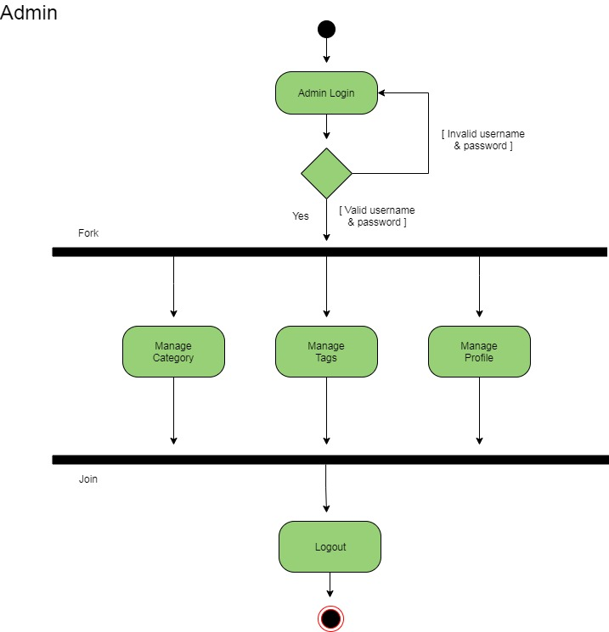

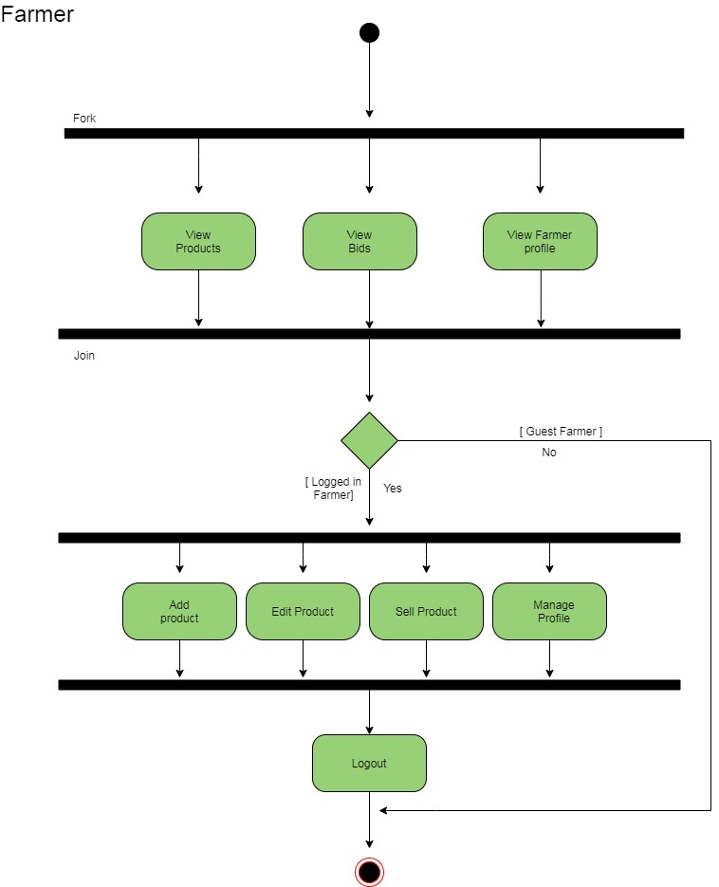

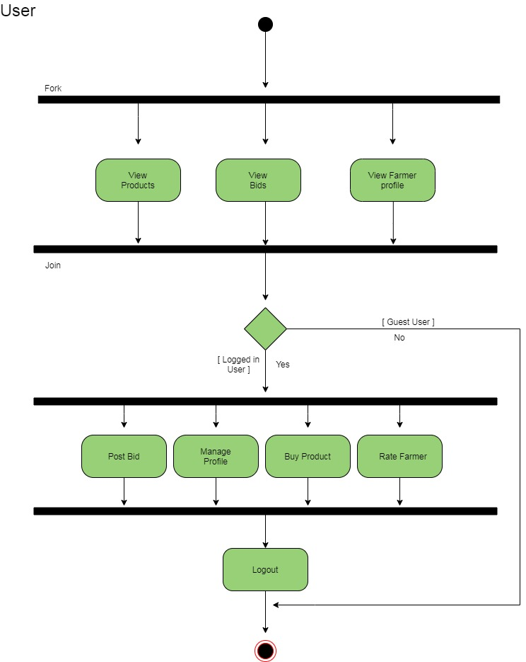

* 1. **Class Diagram**

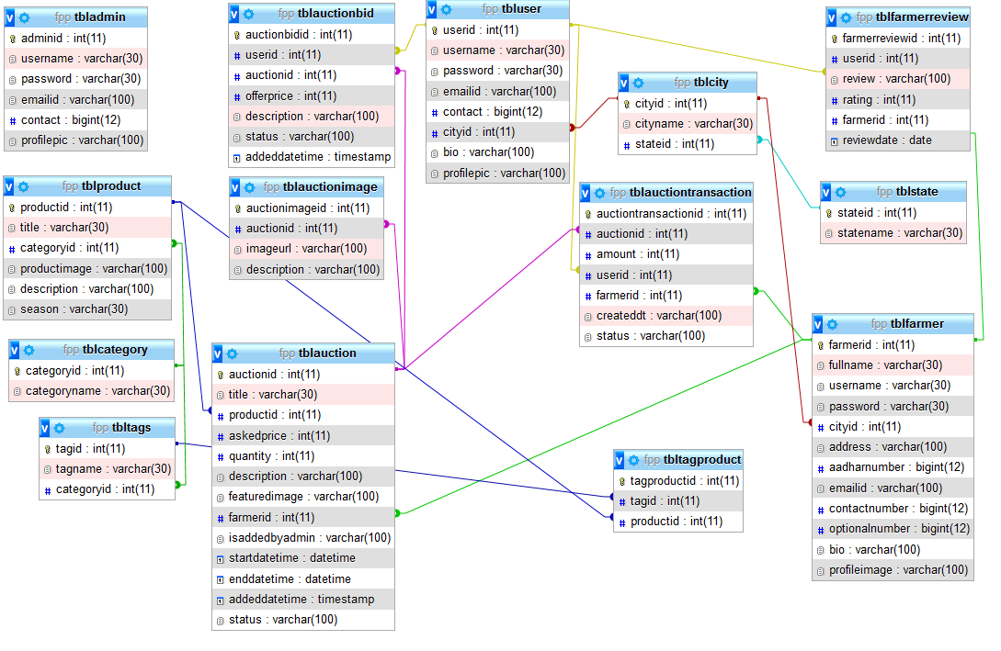

* 1. **Site Map Diagram**

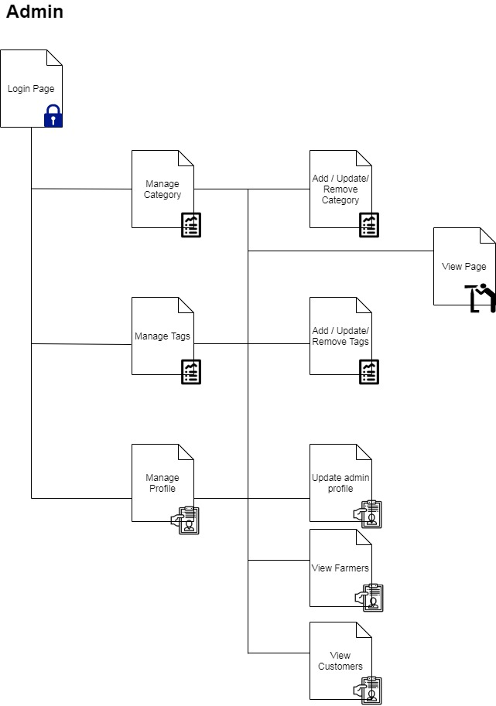

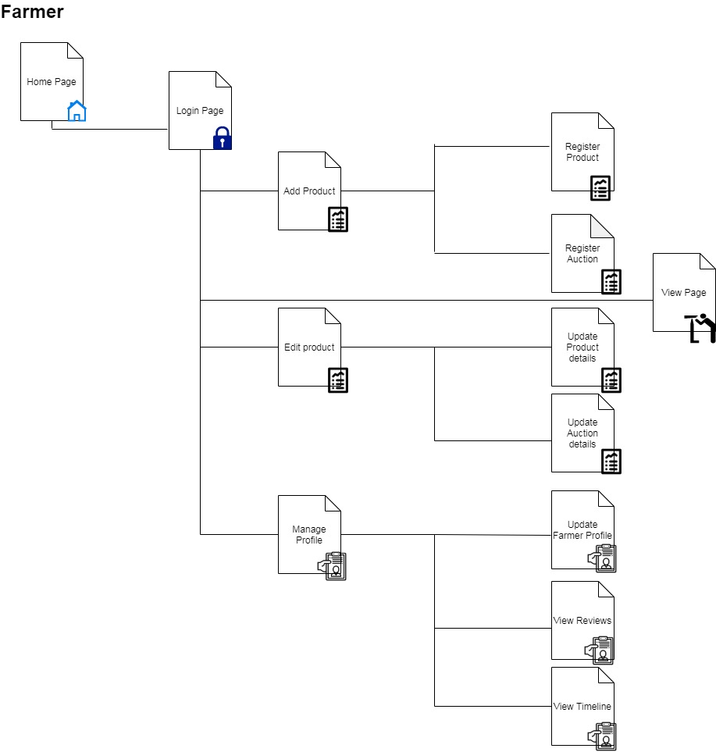

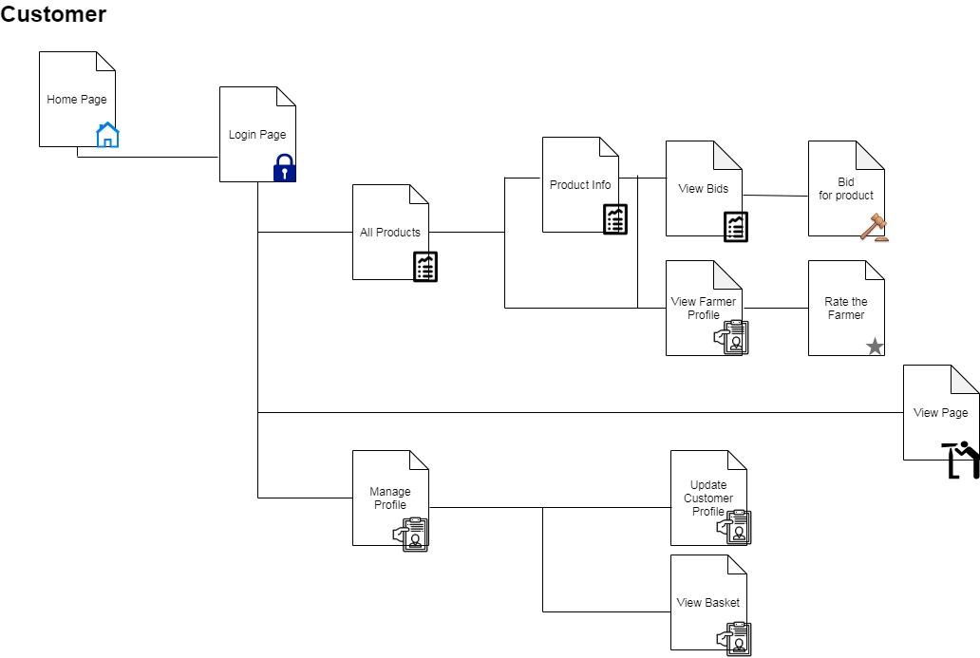

1. **System Planning**
   1. **Duration Feasibility**
   2. **Implementation Feasibility**
   3. **Operational Feasibility**
   4. **Technical Feasibility**
   5. **Resource Feasibility**
   6. **Behavioural Feasibility**
   7. **Economic Feasibility**
   8. **Software Engineering Model**
   9. **Feasibility Study**

Feasibility study involves research relating to different aspects that go into developing software. Feasibility study of the problem definition or requirement was done to determine if the requirement can be solved effectively given the budgetary, operational & technical and scheduled constraints in place. The aim of feasibility study is to identify the best solution under the circumstances by identifying the effects of this solution on the organisation.

The feasibility of our project has been judged on the basis of time, technology, resources available, behavioural feasibility & cost of development.

* 1. **Duration Feasibility**
  + Project initiated with pre-stated deadlines.
  + The duration is allotted keeping in mind the entire task & is practically feasible.
  1. **Implementation Feasibility**

A proper implementation is essential to provide a reliable system to meet requirements of the organization. Implementation is the stage in the project where the theoretical design is turned into a working system. The most critical stage in achieving a new successful system is to improve the performance of the existing system and to deliver system effective application.

* 1. **Operational Feasibility**
* It will help in time saving and fast processing and dispersal.
* From the Admin perspective our application requires basic knowledge about policies of Cyber World.
  1. **Technical Feasibility**
* Minimum system required for admin, user and visitor is computer connected with internet with compatible browser.
* The system is suitable for multi user operations. With the available resources robust system with data security can be developed. It uses PHP which has been tested & approved to be sufficiently robust, scalable & efficient to develop such an application. Hence technically there is no limitation for development of the system.
  1. **Resource Feasibility**
* The system requires well trained software developers. Besides that network connectivity, MySQL servers are needed. Tools for documentation & editing are required.
* These resources are available and feasible.
  1. **Behavioural Feasibility**
* Benefits of proposed system were assessed. Having realized the benefit of new system the users’ response was studied before the inception of system development. They reacted positively towards the proposal.
* Since all the users involved in project development are familiar with internet no explicit training will be required to learn the usage of new system. Simple guidance would suffice.
  1. **Economic Feasibility**
* The cost of software and hardware required for system including storage of bulk of data server.
* No budgetary constraints were imposed on the system. More importantly since all free software were used only hardware, usage & internet costs were to be considered. These were quite limited & well within feasibility.

Based on above study it can be stated that designing & developing this system is certainly feasible if executed well within stated guidelines. So based on these positive results, the new system was approved for development.

* 1. **Software Engineering Model**

We followed Iterative Waterfall Model for software development do we can add new functionalities as per requirement.

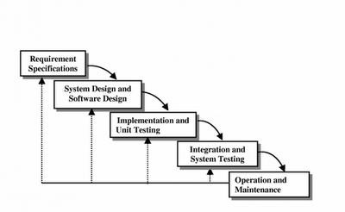

**6. Test Cases**

**6.1 Admin Side**

**6.2 User Side**

**6.1 Admin Side**

|  |  |  |  |  |  |
| --- | --- | --- | --- | --- | --- |
| **Sr.no.** | **Objective** | **Input Value** | **Valid/Invalid** | **Expected Result** | **Generated Result** |
| 1. | Admin Login | string | Valid: Registered Username and password.  Invalid: Invalid Credentials passed. | Admin home must open up on valid login.  Else Login failure. | Admin home opens up on valid login.  Else Login failure. |
| 2. | Edit Category | string | Valid: Any string input.  Invalid: Non-string input. | Change must be reflected on user side. | Change is reflected on user side. |
| 3. | Delete Category | String | Valid: When no category has any dependency  Invalid: When category has dependency . | Change must be reflected on user side. | Change is reflected on user side. |

**6.2 User Side**

**Farmer**

|  |  |  |  |  |  |
| --- | --- | --- | --- | --- | --- |
| **Sr.no.** | **Objective** | **Input Value** | **Valid/Invalid** | **Expected Result** | **Generated Result** |
| 1. | Farmer Registration | string | Valid: Unique Username and password.  Invalid: Username already taken up passed. | Farmer login must open up on valid login.  Else registration failure. | Farmer login opens up on valid login.  Else registration failure. |
| 2. | Farmer Login | string | Valid: Registered Username and password.  Invalid: Invalid Credentials passed. | User home page must open up on valid login.  Else Login failure. | User home page opens up on valid login.  Else Login failure. |
| 3. | Farmer Post Auction | String, Integer, Float. | Valid: When all details are entered properly.  Invalid: when Any one detail is left blank. | Change must be reflected on Home Page. | Change is reflected on Home Page. |
| 4. | Farmer Edit Auction | String, Integer, Float | Valid: When Auction has not started yet or auction is in progress.  Invalid: When Auction Has finished. | Change must be reflected on Home Page. | Change is reflected on Home Page. |

**Customer**

|  |  |  |  |  |  |
| --- | --- | --- | --- | --- | --- |
| **Sr.no.** | **Objective** | **Input Value** | **Valid/Invalid** | **Expected Result** | **Generated Result** |
| 1. | Customer Registration | string | Valid: Unique Username and password.  Invalid: Username already taken up passed. | Customer login must open up on valid login.  Else registration failure. | Customer login opens up on valid login.  Else registration failure. |
| 2. | Customer Login | string | Valid: Registered Username and password.  Invalid: Invalid Credentials passed. | User home page must open up on valid login.  Else Login failure. | User home page opens up on valid login.  Else Login failure. |
| 3. | Customer Post Bid | String, Integer | Valid: When Bid price is higher than last bid and minimum value.  Invalid: When Bid price is less than last bid and minimum value. | Change must be reflected on Auction Board. | Change is reflected on Auction Board. |

1. **Limitations**

* Not all the farmers might be able to use the website due to the language constraint.
* The website doesn’t deal with smaller quantity purchase demands.
* The customer doesn’t have the option of paying the price in installments.

1. **Future Enhancements**

* Payment Gateway can be used to carry out the transactions.
* Transport facility can be made available for the products to reach the customers.
* Customer and Farmer interaction can be made possible by using on website messaging.

1. **Screen Shots**

* **Admin Side**

**Home Page**

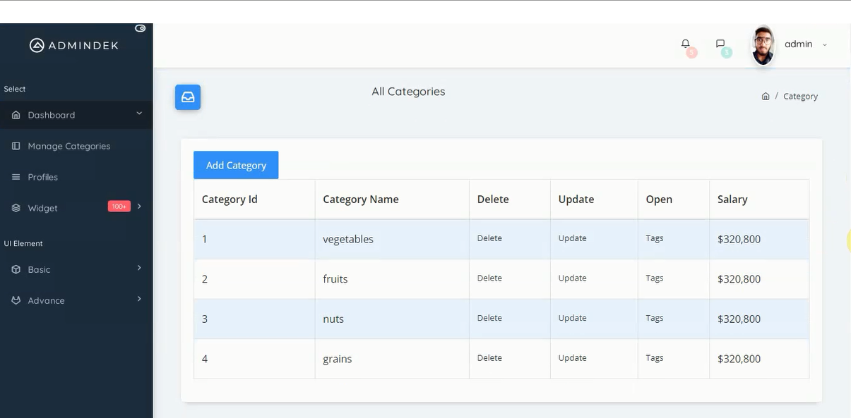

**View Profiles**

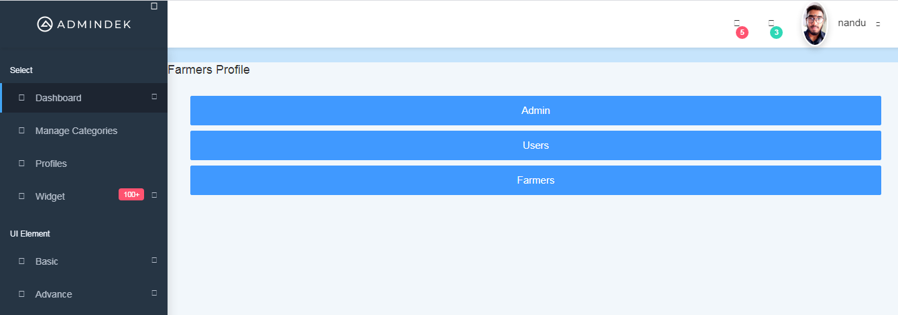

**Update Profile (Personal)**

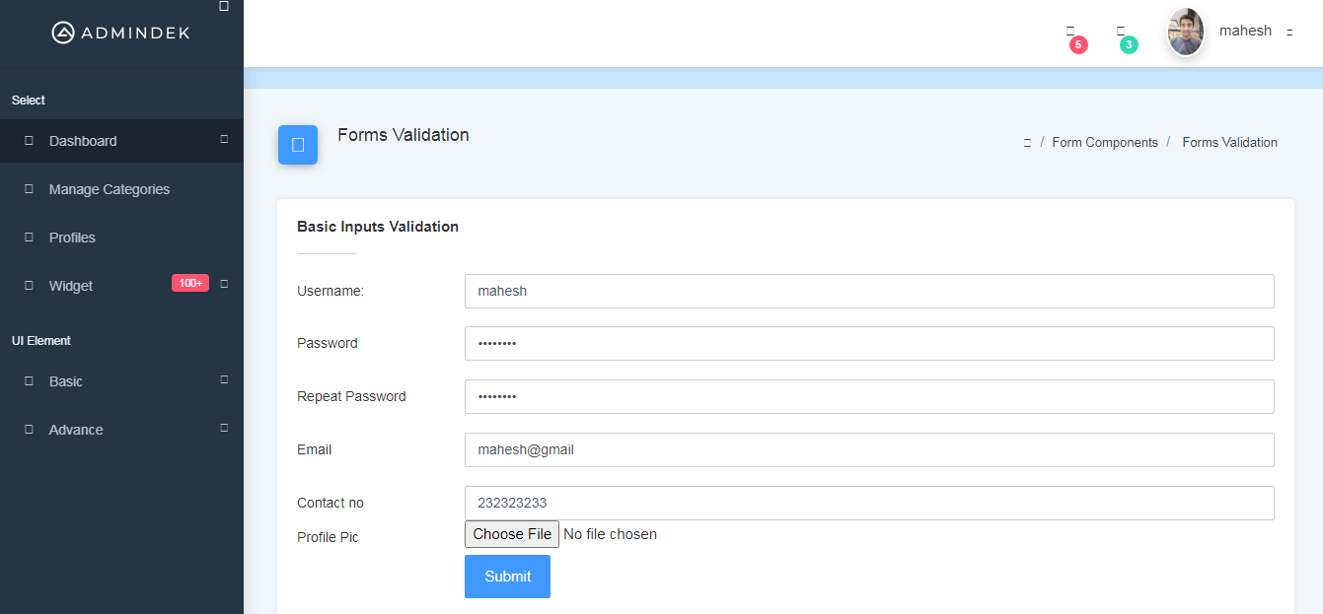

* **User Side**

**Home Page**

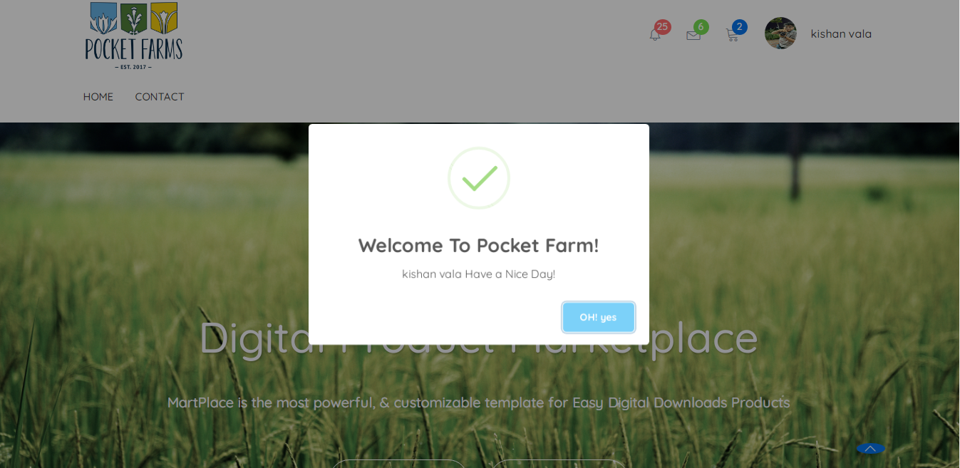

**Active Auctions**

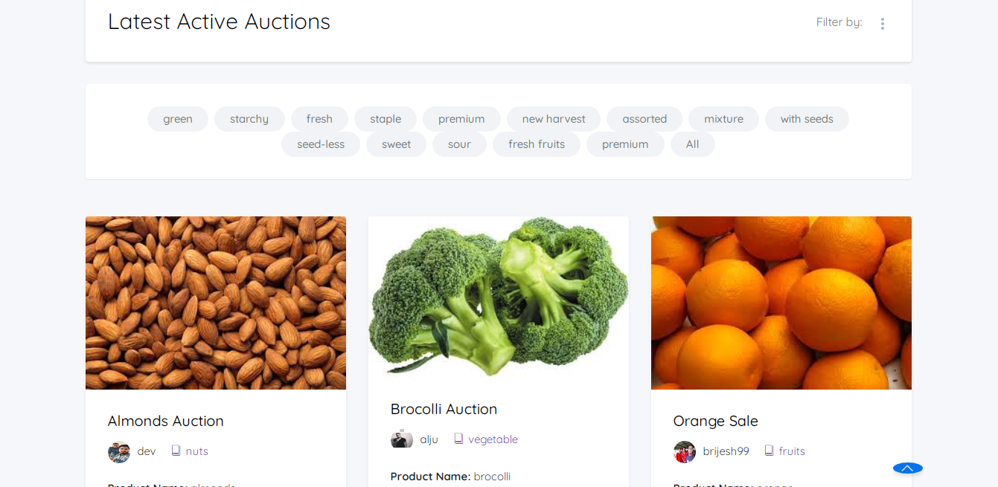

**Past Auctions**

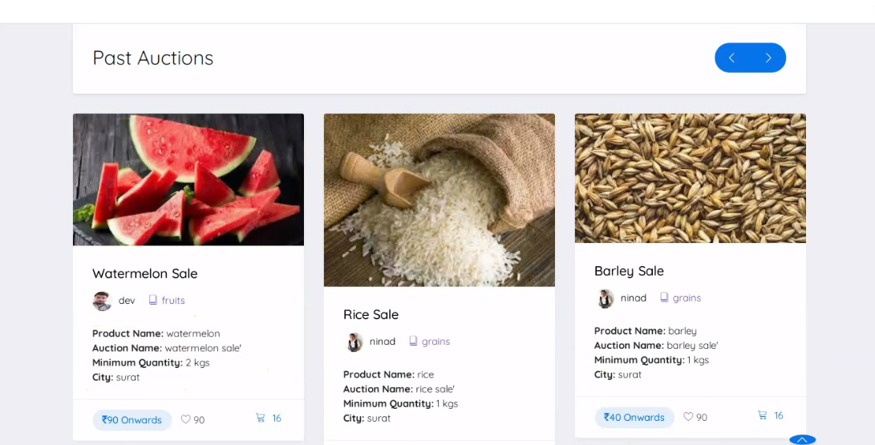

**View Product**

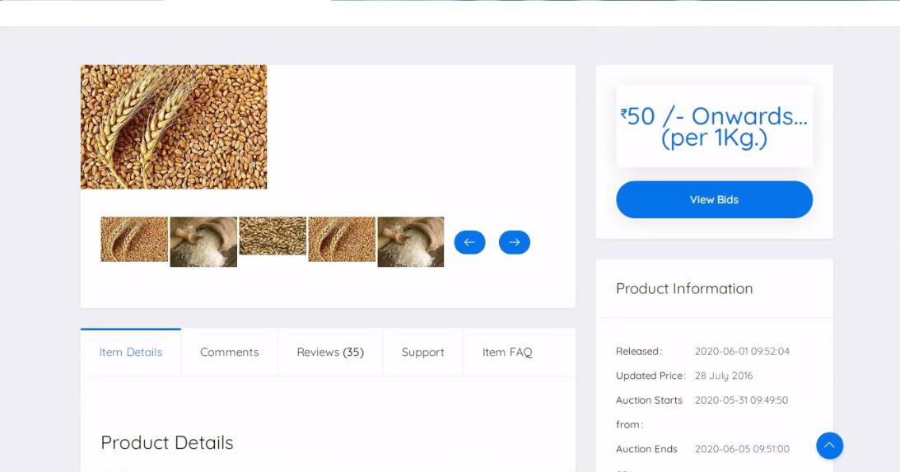

**Bidding Page**

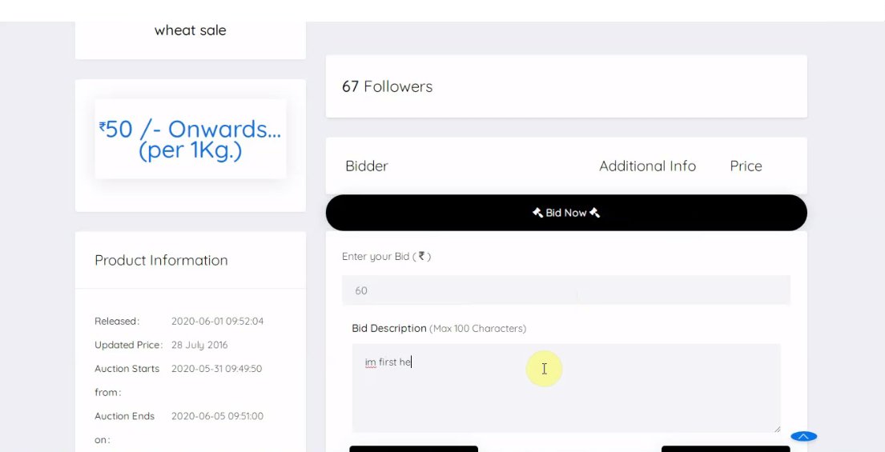

**Post Auction( Farmer)**

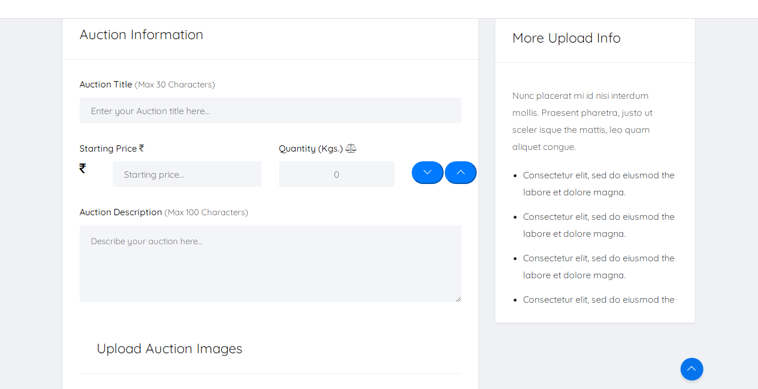

**Edit Profile**

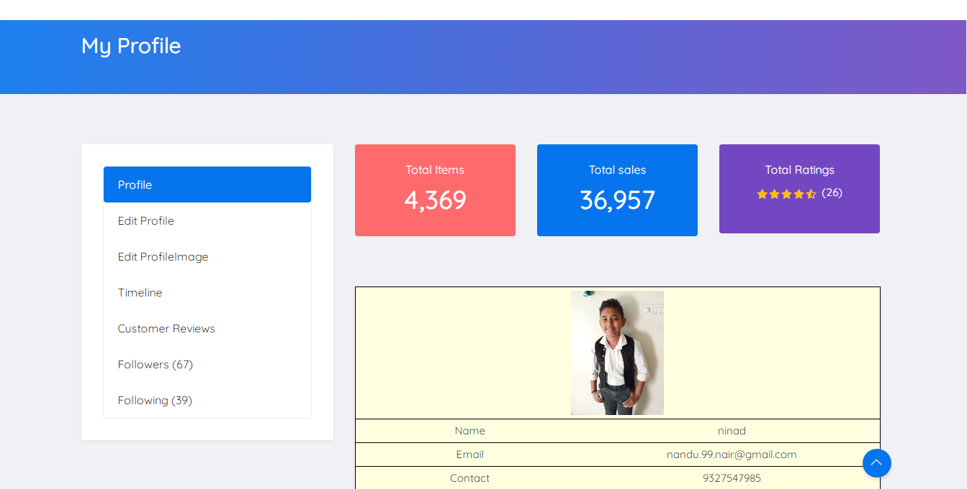

**Edit Product**

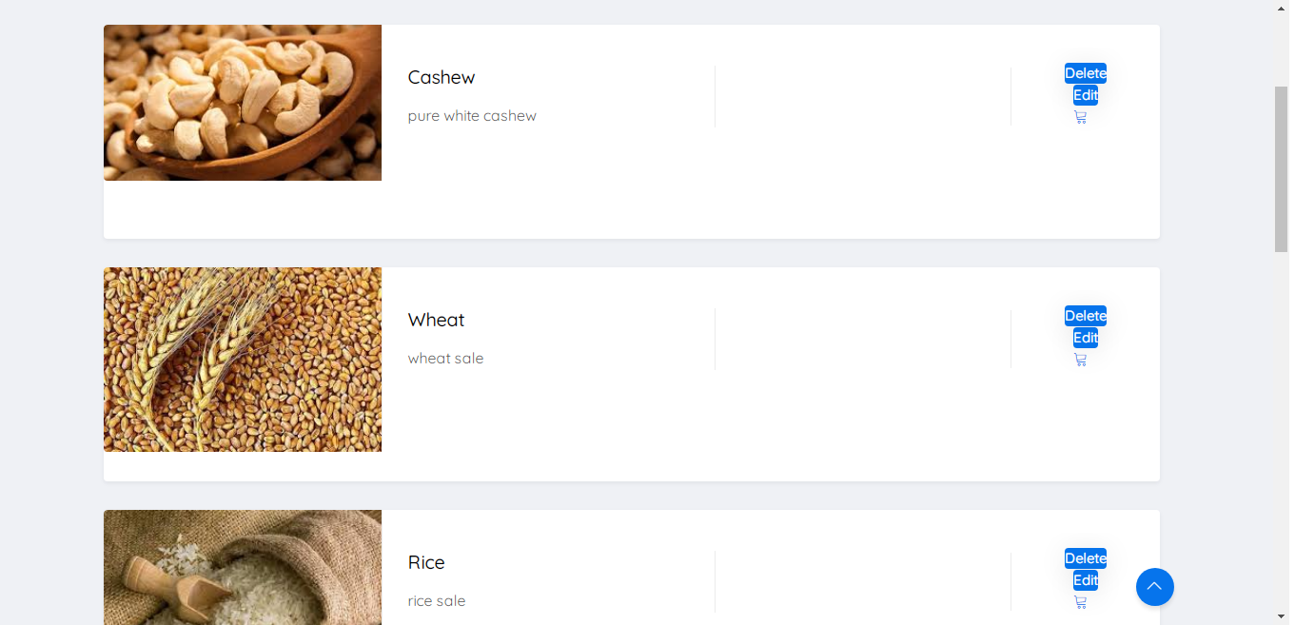

**Customer Profile**

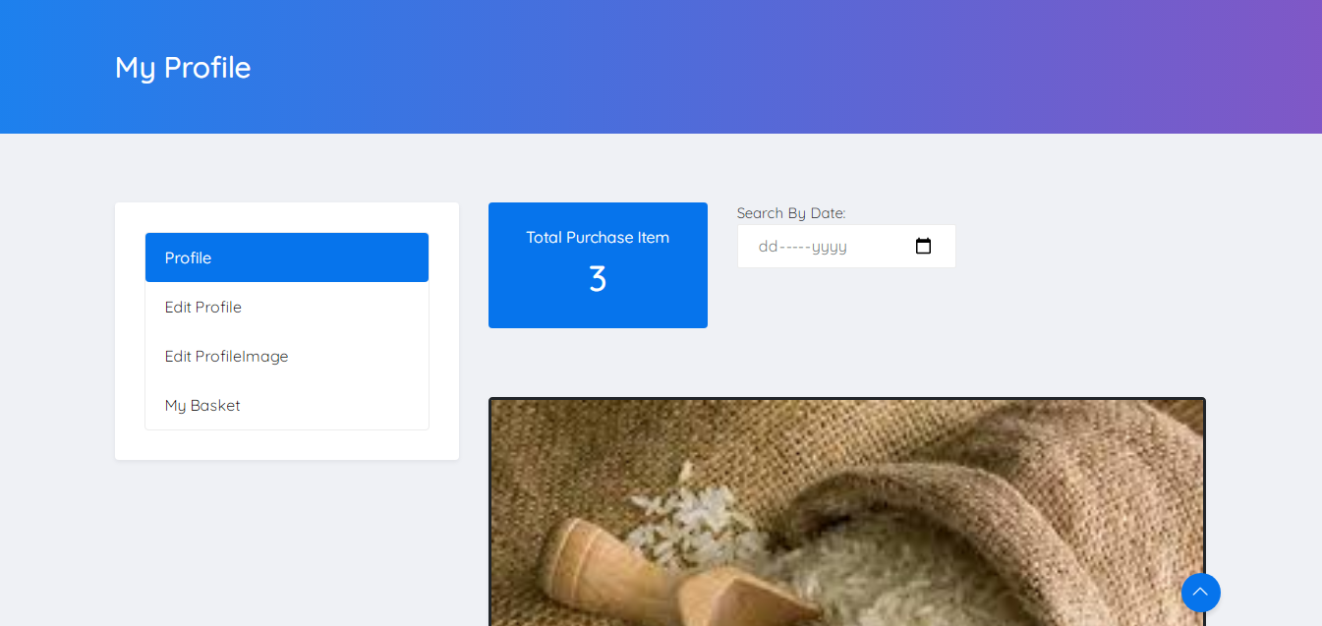

**Customer Reviews**

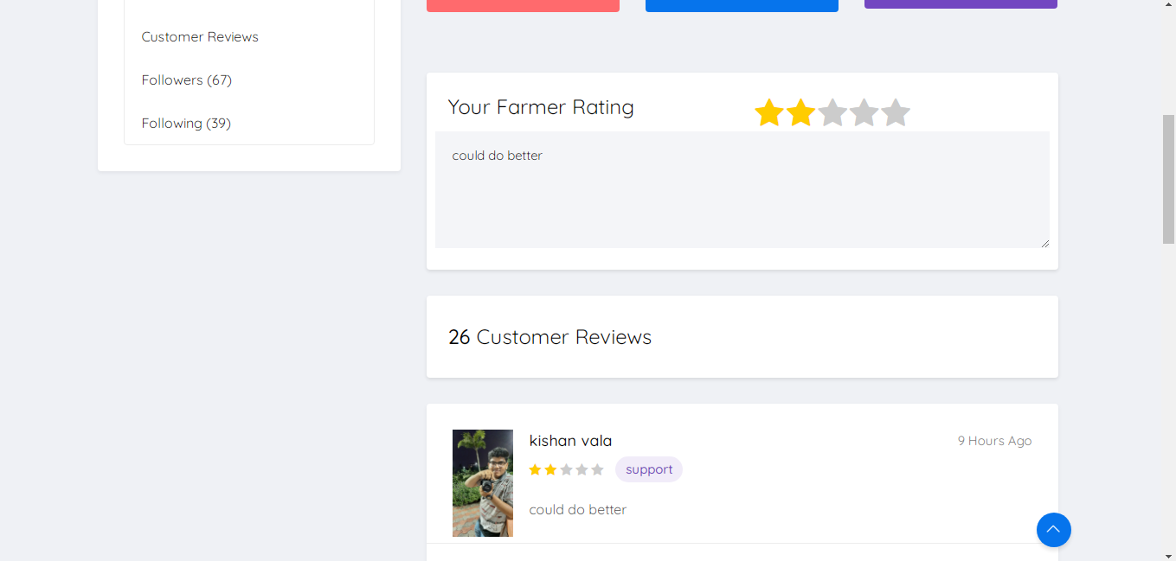

**Contact Us**

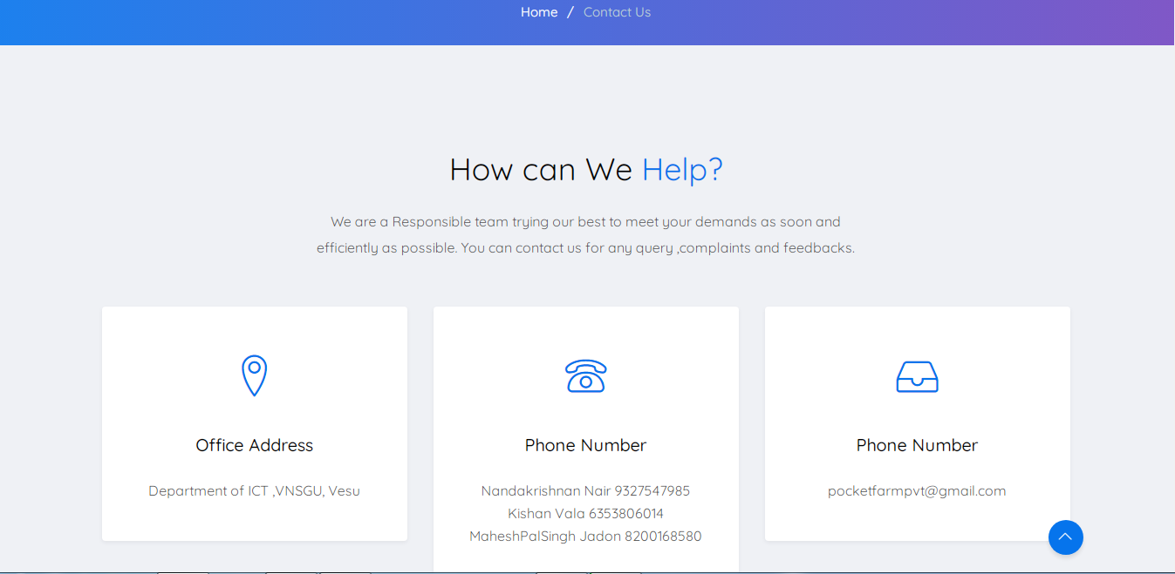

**Transaction Statement through SMS**

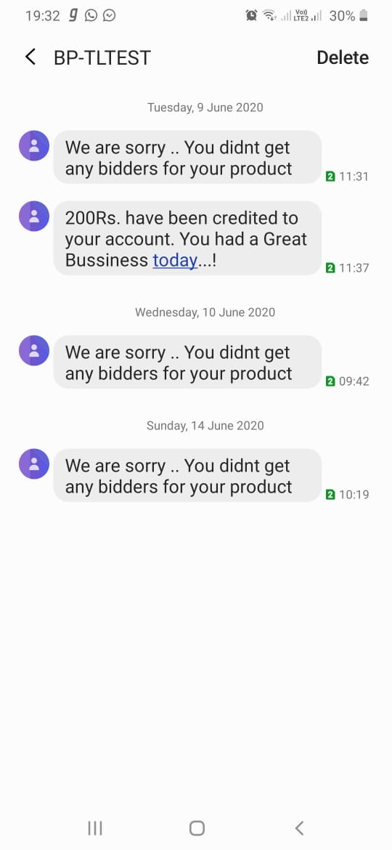

**10. References**

[www.wikipedia.com](http://www.wikipedia.com/) [www.w3layouts.com](http://www.w3layouts.com/)

<https://www.geeksforgeeks.org/>

[www.w3schools.com](http://www.w3schools.com/) [www.stackoverflow.com](http://www.stackoverflow.com/)

[www.quora.com](http://www.quora.com)